Q1

Do you work in Web Development or for a recruitment agency?

* Other (please specify):
* Assistant Manager - Perry
* Factory Worker - Will
* Sys Ops - Tom

Q2

Who would you expect to use this site?

Potential employers. Potential clients and customers. Other developers. Site owner.

Q3

Are there any items you would add to the card sort?

Quotes/reviews from customers and clients. Contact info, might be on there but needs to be clearer. 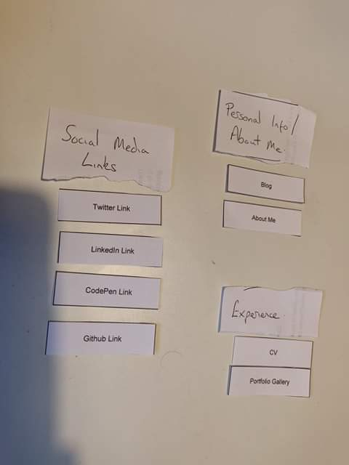

Q4

Please provide a name and a way to contact you